1. **Agenda**:  
   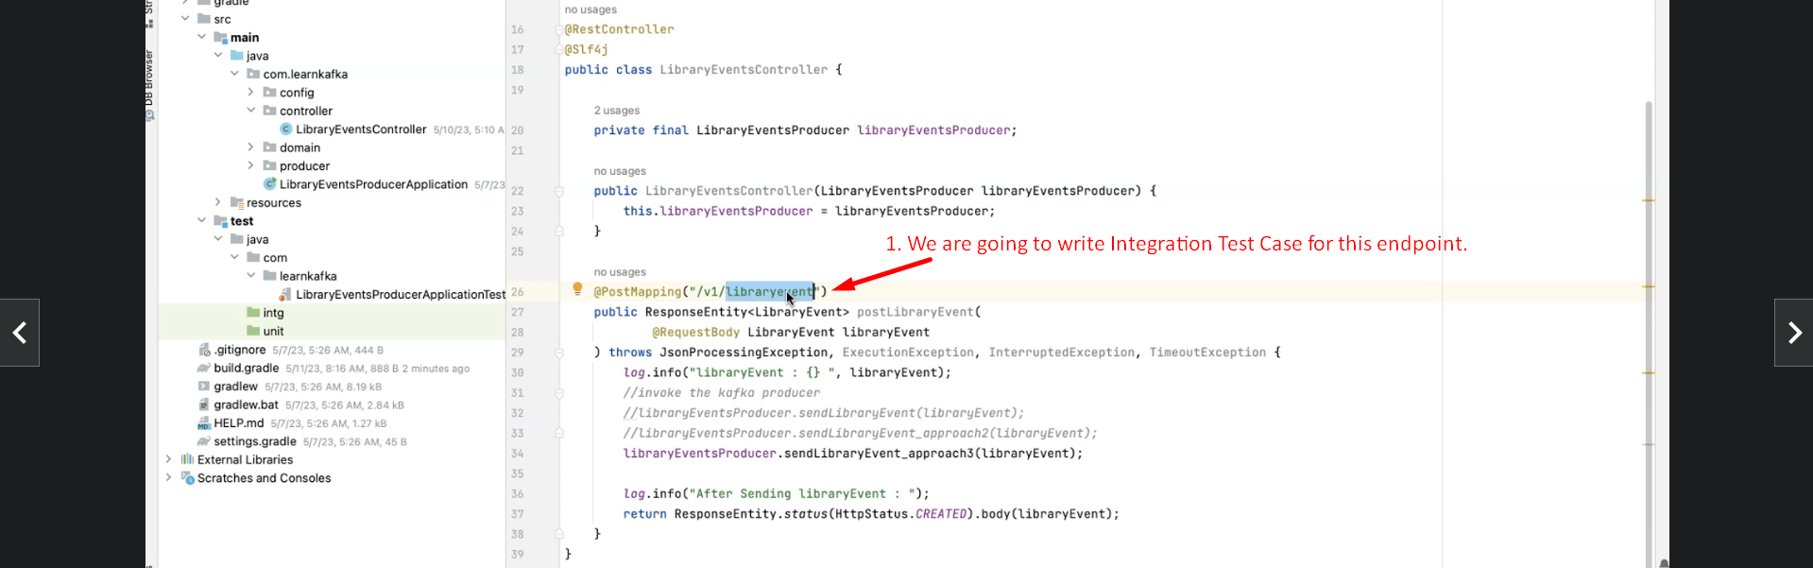
2. **Right click on the controller class to create a skeleton test class**.   
   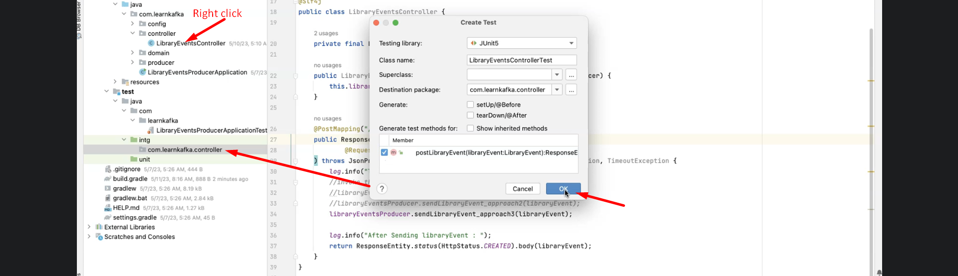
3. 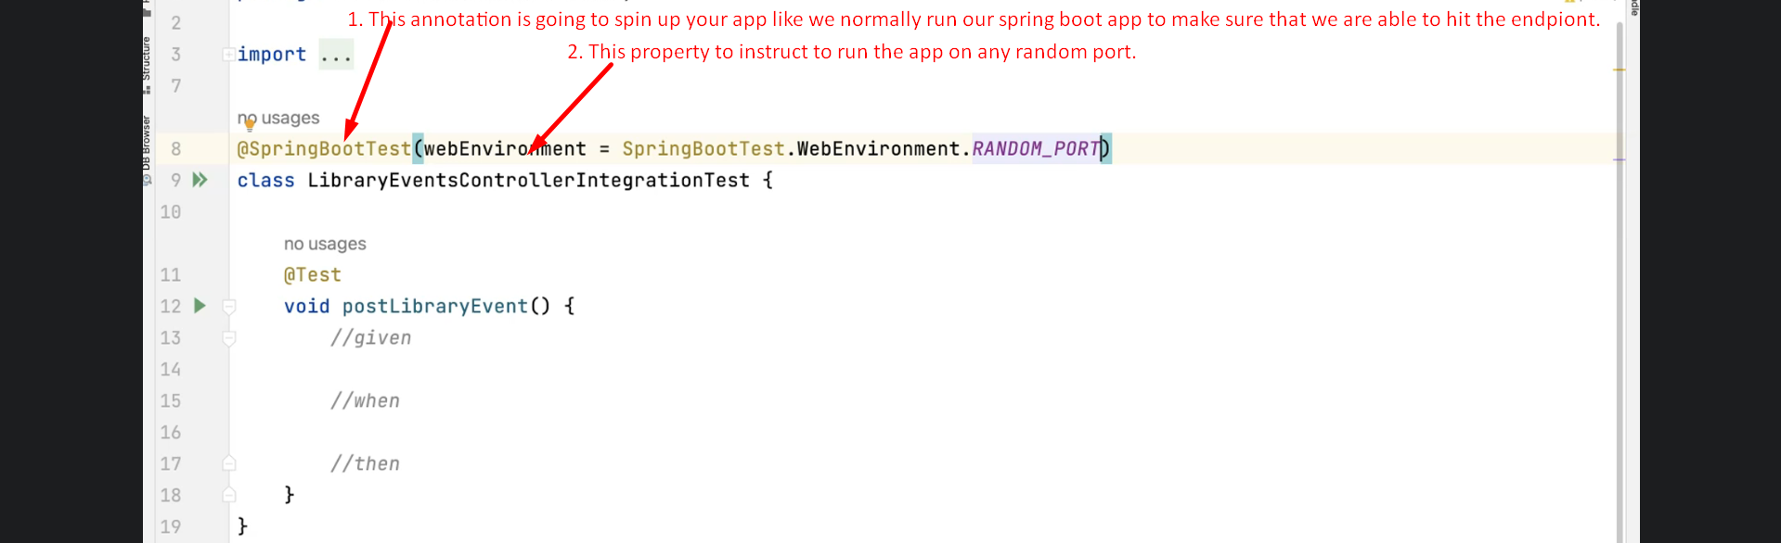
4. 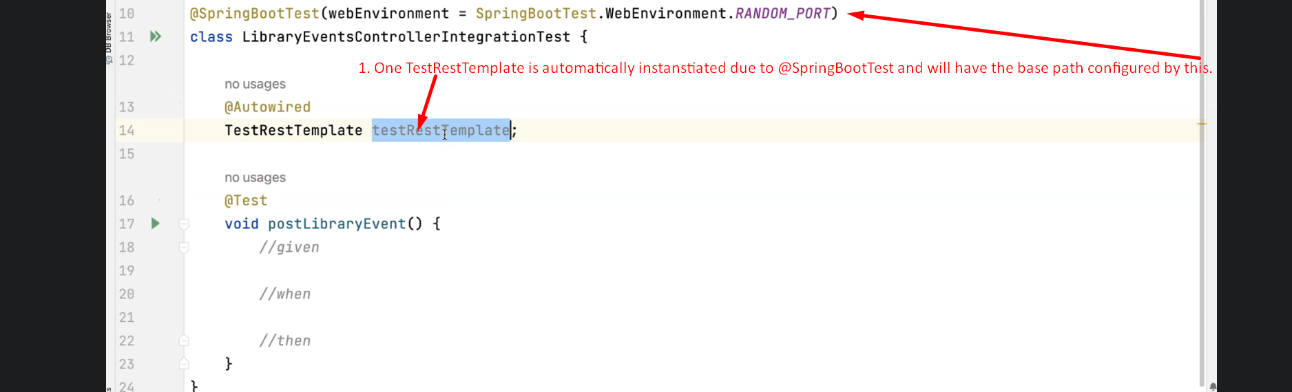
5. 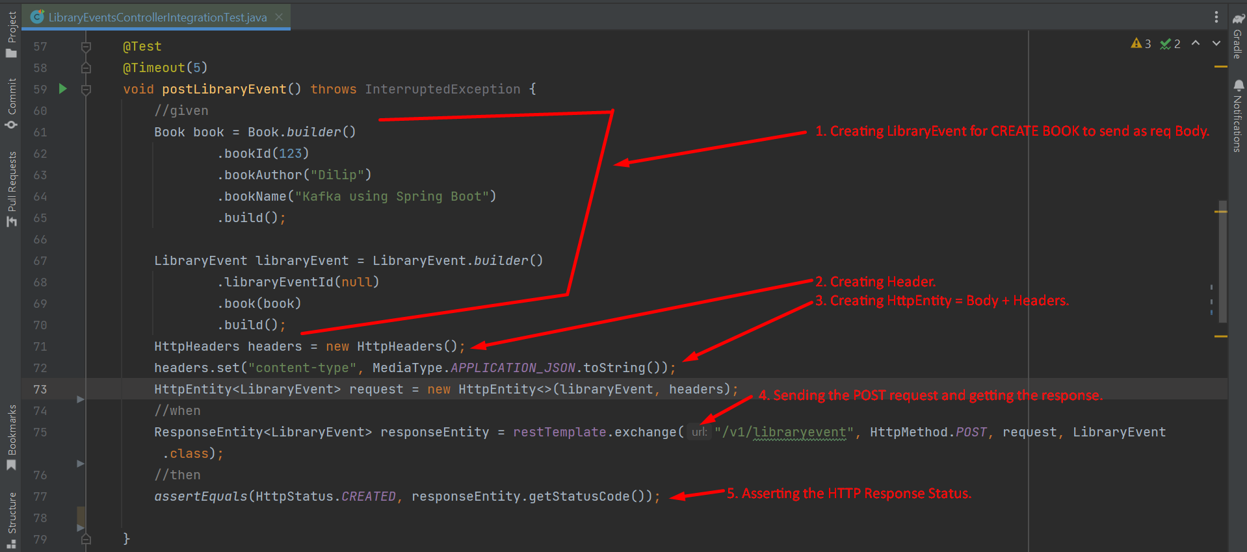
6. The message will not be delivered to Kafka Topic as we don’t have any broker up to publish the msg.  
   Let’s configure an embedded broker in next lecture.